If you want to know genderwise salary

1. In sql

Select gender,sum(salary) from employee group by gender

1. In data flow
2. Create source
3. Then click on + select aggregate

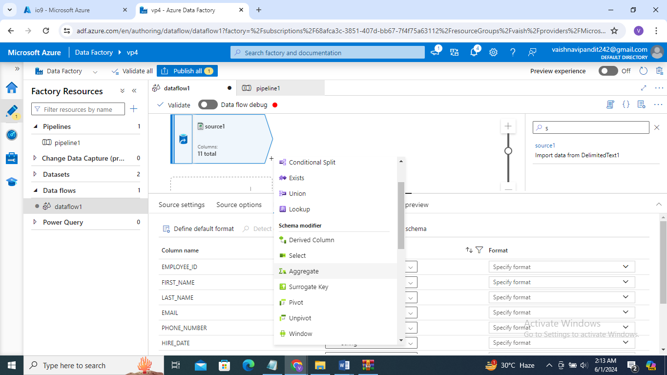

1. GO TO aggregate group by select column you want to group by

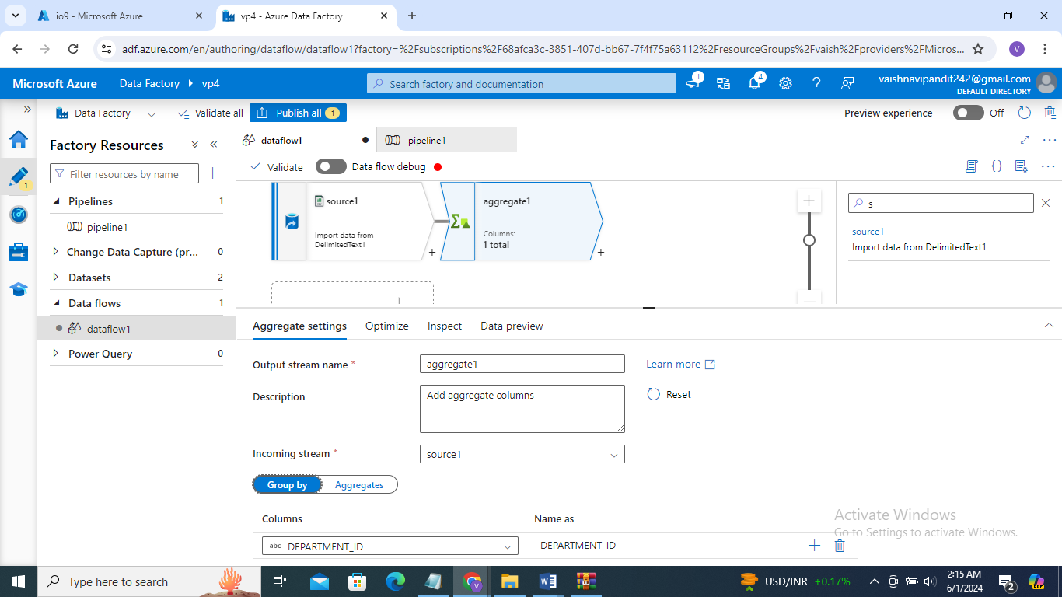

1. Then go to aggregate to get sum of slary column

Select column name and enter expression as sum(salary) but as salary in in string format we have to convert it to the integer go to the + after source and select cast

Then cast salary from string to integer

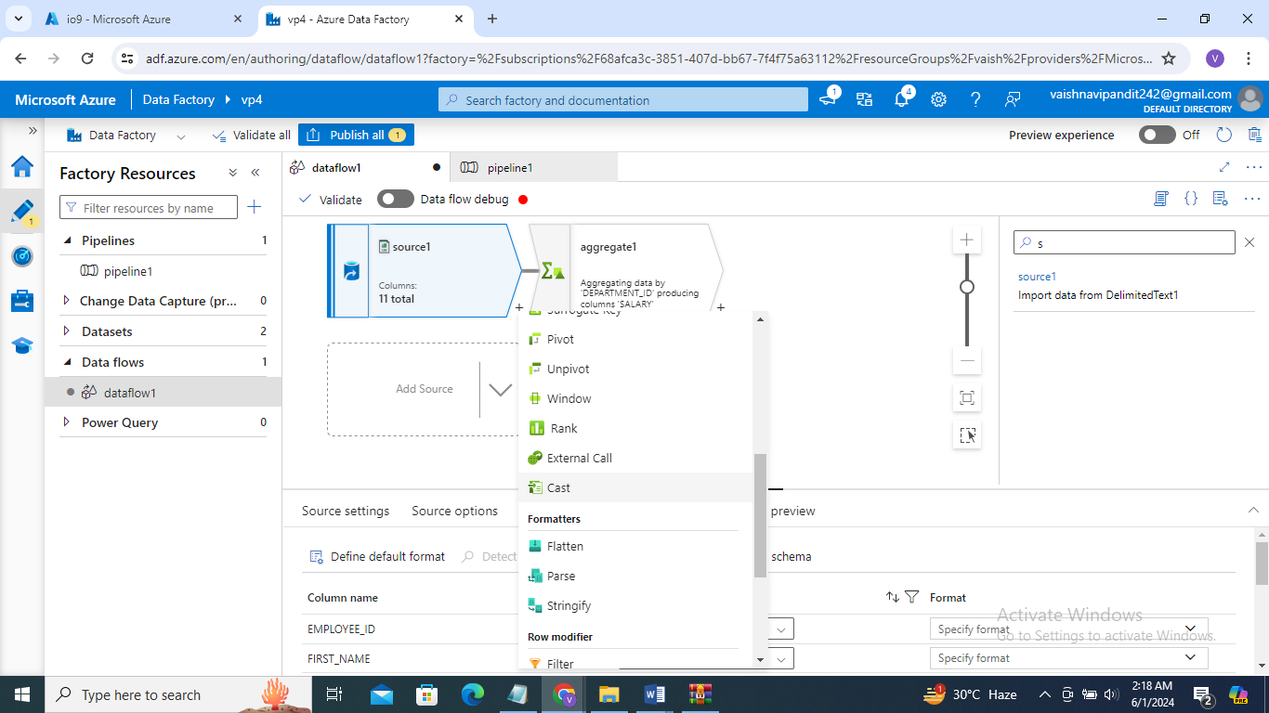

1. Go into cast and add column name you want to cast and to which data type

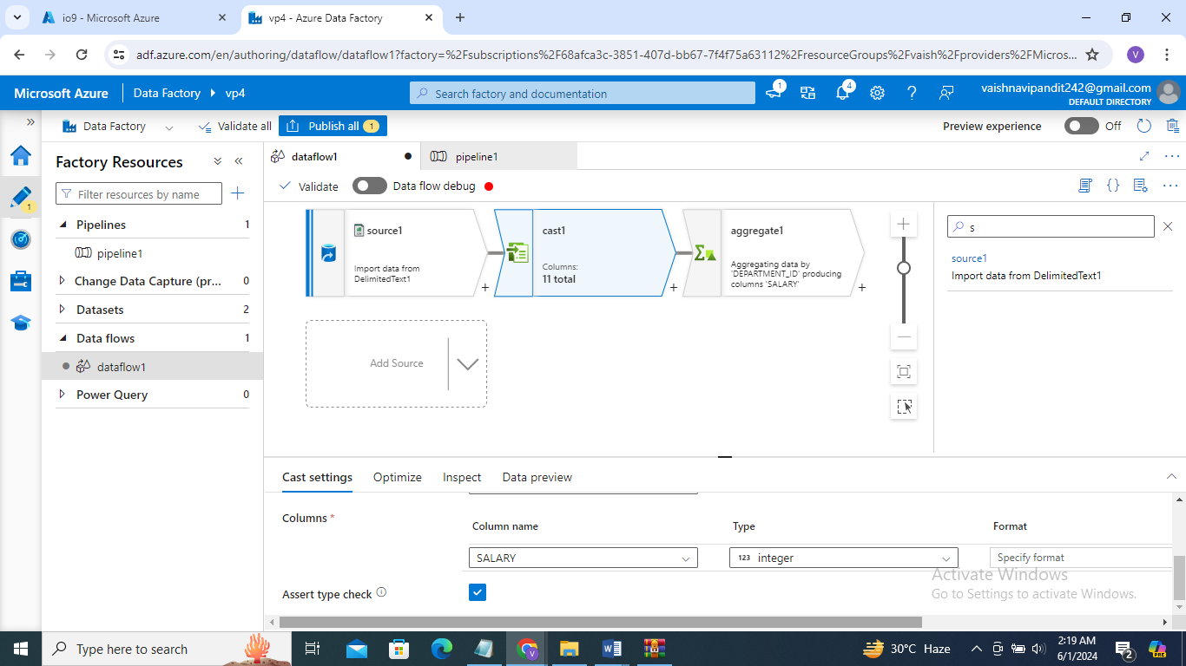

1. Now go to aggeregate again and write sum function for salary

Open expression builder sum(salary)

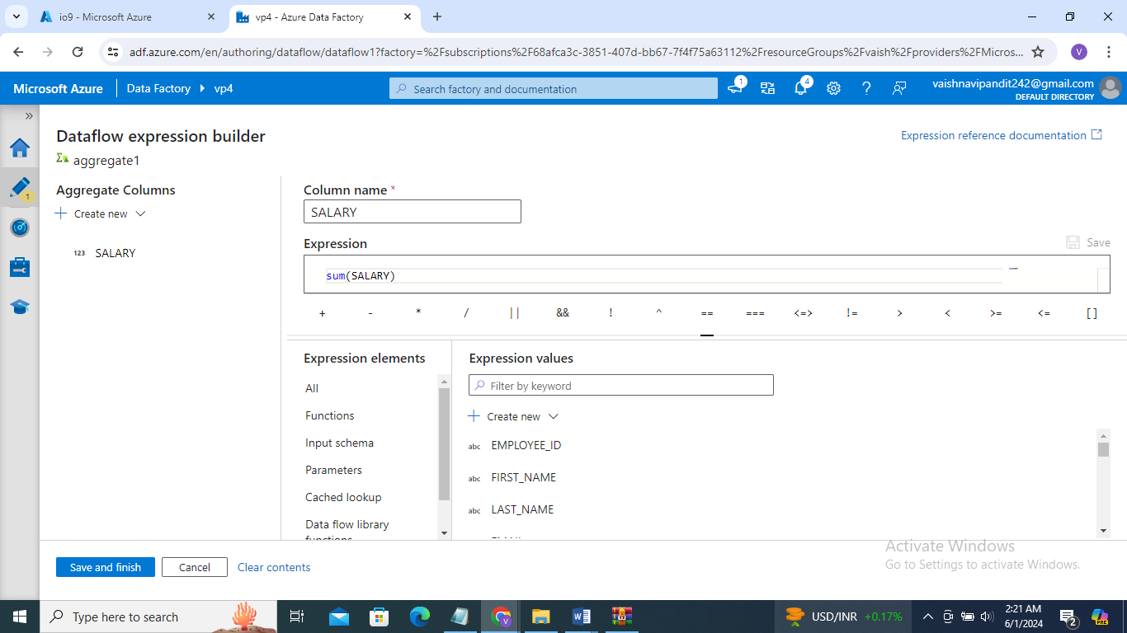

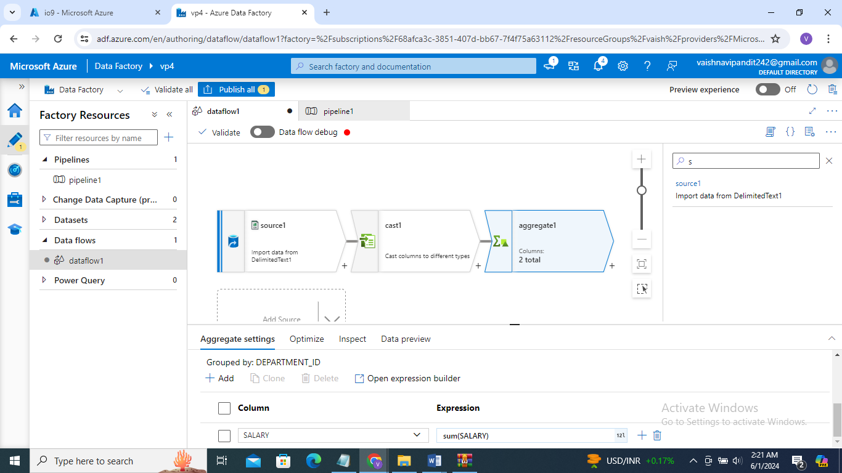

1. Then add sink and pipeline as previously we did to load it to file in adls